**Defect Logs:**

**Debugging Tools in Action:**

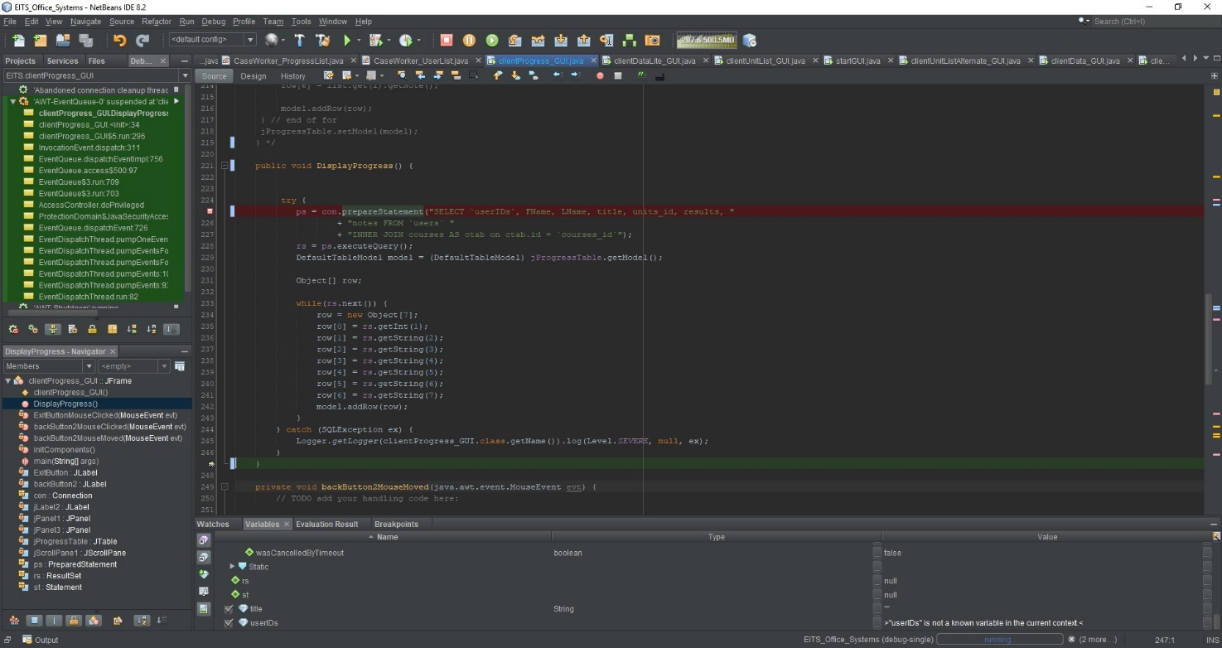**Jakob Debugging:**

**Solution:** JAKOB - "The solutions applied to correct my error was to rename the variables to be the same as what is in the database."

**Brayden Debugging:**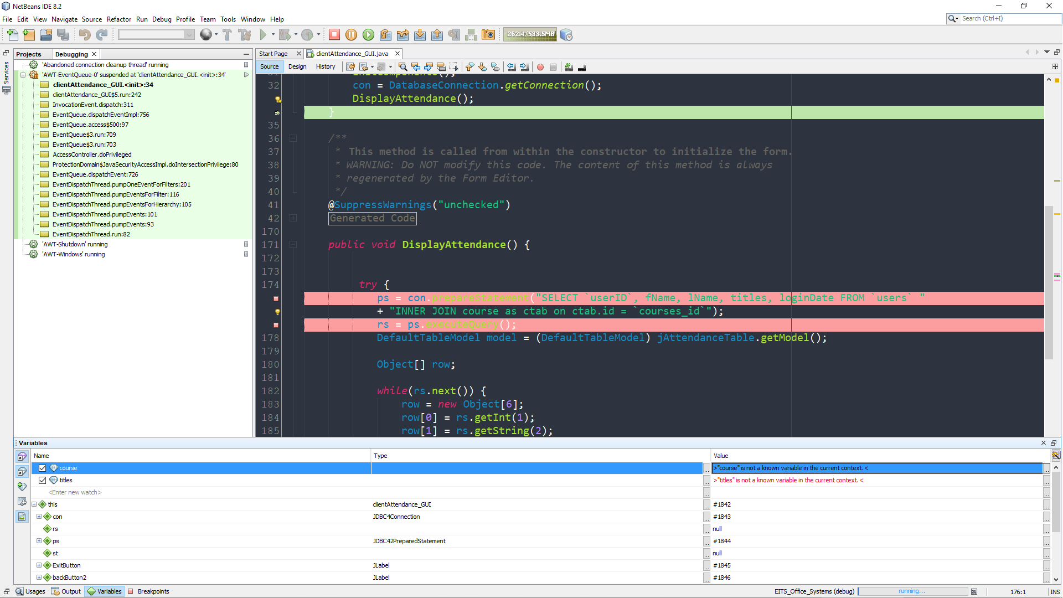

**Solution:** Brayden - "The solutions that I had gathered and applied in order to fix the SQL error due to incorrect values within the statement include primarily renaming the values within the statement to the corresponding values that are within the database. "

**Alex Debugging:**

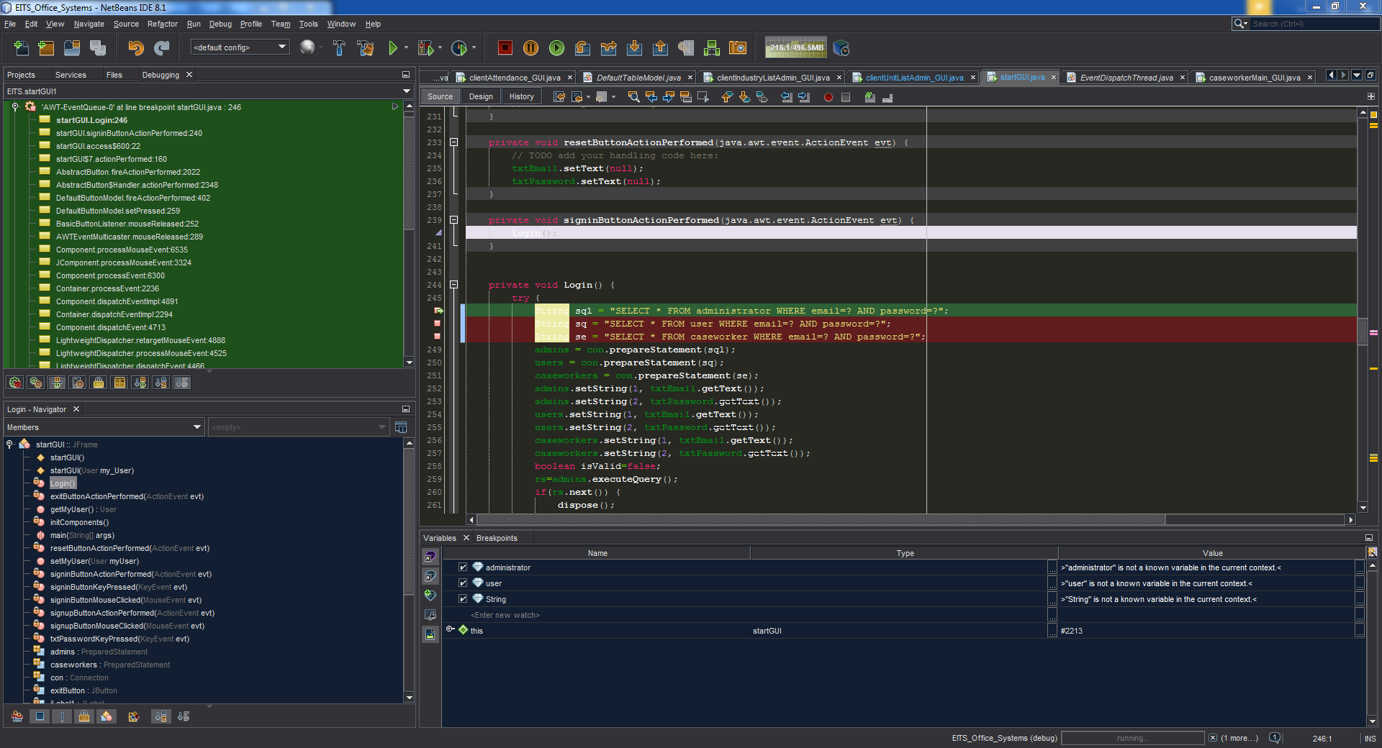

**Solution:** Alex – “The solutions I used was to change the administrator value to match the correct context, and same with the User and String.